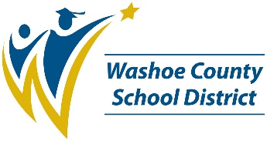**Loder Elementary School**

*2023-2024 SCHOOL PERFORMANCE PLAN*

**Student Success Goal**

By June 2024 EL students will increase overall proficiency on SBAC by 5 percentage points.

To support students to achieve this goal, we will:

1. Ensure use of Benchmark curriculum during walkthroughs and review of lesson plans.
2. Teachers will receive PD on specific ELLevations strategies to be used each quarter as an extra layer of support with the district’s ELA curriculum.

**Student, Staff, and Family Partnerships Goal**

By June of 2024 Echo Loder will see a decrease of 5% in chronic absenteeism and a 2% decrease in severely chronic absenteeism rates.

To support students and families to achieve this goal, we will:

1. Administration will run weekly attendance reports.
2. Attendance clerk will make daily calls for those who have unverified absences for the day.
3. Individual classrooms can win prizes when they meet a goal of 15 days with 100% attendance.
4. Use of school-based attendance monitors to track attendance.
5. School will provide resources to help support student attendance.

**Resources for Parents and Families**

| **Quick Tips for Parents and Families** |  | **Resource Links** |
| --- | --- | --- |
| **Get involved!** Contact Sandra Allen for information about volunteering with our school. |  | **Infinite Campus Parent Portal**  *See your child’s grades, assignments, attendance information and important updates*  **www.washoeschools.net/ICparent** |
| **Stay connected!** Let the front office know if your phone number, email or home address has changed. |  | **Family Resource Centers**  *Basic needs assistance, resource referrals, and help with accessing services like SNAP*  **www.washoeschools.net/FRC** |
| **Know your child’s teachers!** We are here to support your child’s learning journey. |  | **Care Solace**  *Free and confidential help to access mental health care providers in your community*  **www.washoeschools.net/Care** |